# Theme

## warwickclean

### Navigation menu

- Links on the navigation menu are hard-coded. They are in

renders/core_renderer.php

- The navigation block has been hidden (set not to show) on the front page.

For the navigation menu to show, Moodle settings have to be changed:

Site Administration->Appearance->Theme->Theme settings

in *Custom menu items* add *Front Page|/?redirect=0*

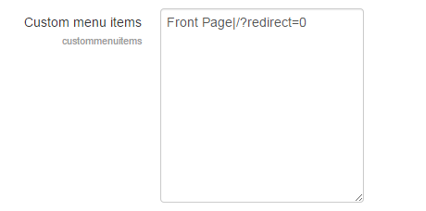

On Moodle 2

core_renderer.php has been modified to remove the categories in the menu. See Moodle2 documentation (moodle2.docx) for details.